FINALTERM EXAMINATION
MTH301- Calculus II

Question No: 1 ( Marks: 1 ) - Please choose one

  - Intersection of two straight lines is --------------

► Surface

► Curve

      - ► Plane

      - ► Point

Question No: 2 ( Marks: 1 ) - Please choose one

Plane is a --------------- surface.

► One-dimensional

► Two-dimensional

► Three-dimensional

► Dimensionless

Question No: 3 ( Marks: 1 ) - Please choose one

Let w = f(x, y, z) and x = g(r, s), y = h(r, s), z = t(r, s) then by chain rule
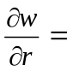

► 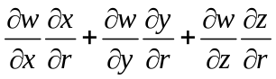

► 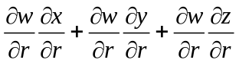

► 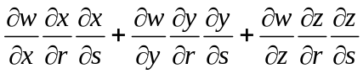

► 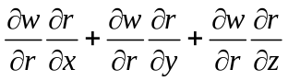

Question No: 4 ( Marks: 1 ) - Please choose one

What are the parametric equations that correspond to the following vector equation?
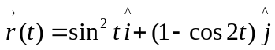

► 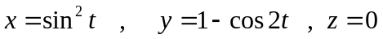

► 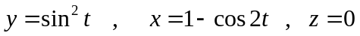

► 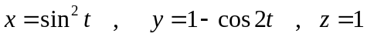

► 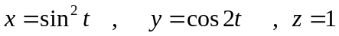

Question No: 5 ( Marks: 1 ) - Please choose one

What are the parametric equations that correspond to the following vector equation?
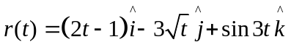

►

►

►

►

Question No: 6 ( Marks: 1 ) - Please choose one

What is the derivative of following vector-valued function?
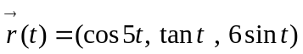

► 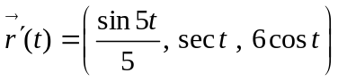

► 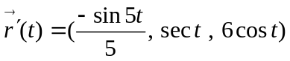

► 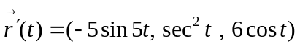

► 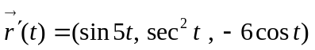

Question No: 7 ( Marks: 1 ) - Please choose one

What is the derivative of following vector-valued function?
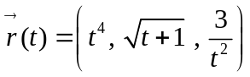

► 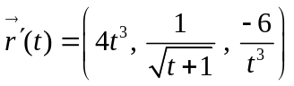

► 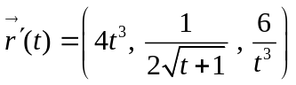

► 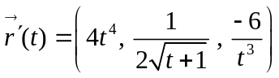

► 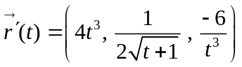

Question No: 8 ( Marks: 1 ) - Please choose one

The following differential is exact
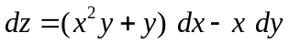

► True

► False

Question No: 9 ( Marks: 1 ) - Please choose one

Which one of the following is correct Wallis Sine formula when is even and ?

► 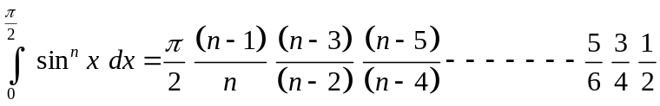

► 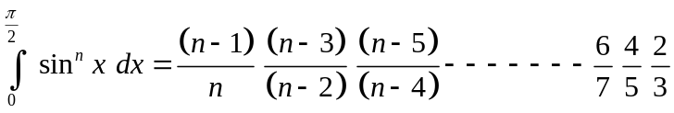

► 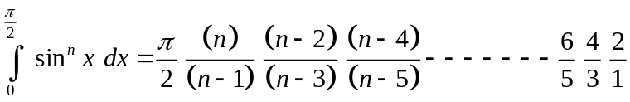

► 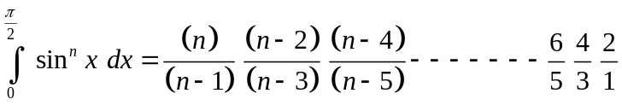

Question No: 10 ( Marks: 1 ) - Please choose one

Match the following equation in polar co-ordinates with its graph.
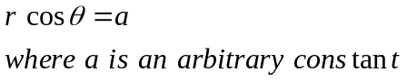

► 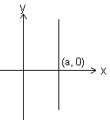

► 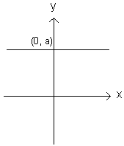

► 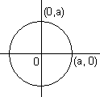

► 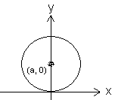

Question No: 11 ( Marks: 1 ) - Please choose one

If the equation of a curve, in polar co-ordinates, remains unchanged after replacing 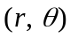by 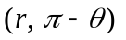then the curve is said to be symmetric about which of the following?

► Initial line

► y-axis

► Pole

Question No: 12 ( Marks: 1 ) - Please choose one

If the equation of a curve, in polar co-ordinates, remains unchanged after replacing by 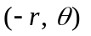then the curve is said to be symmetric about which of the following?

► Initial line

► y-axis

► Pole

Question No: 13 ( Marks: 1 ) - Please choose one

What is the amplitude of a periodic function defined by 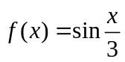?

► 0

► 1

►

► Does not exist

Question No: 14 ( Marks: 1 ) - Please choose one

What is the period of a periodic function defined by 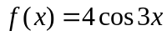?

► 

► 

► 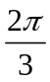

►

Question No: 15 ( Marks: 1 ) - Please choose one

Match the following periodic function with its graph.
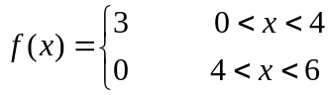

► 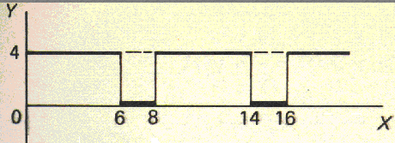

► 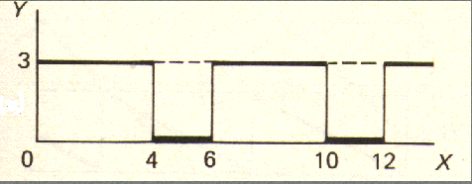

► 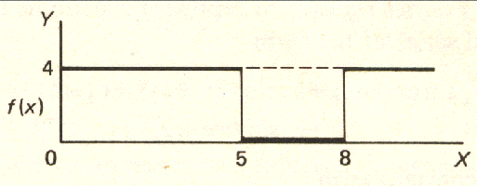

► 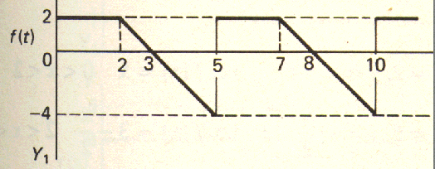

Question No: 16 ( Marks: 1 ) - Please choose one

What is the period of periodic function whose graph is as below?

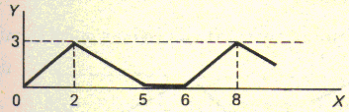

► 2

► 5

► 6

► 8

Question No: 17 ( Marks: 1 ) - Please choose one

What is the period of periodic function whose graph is as below?
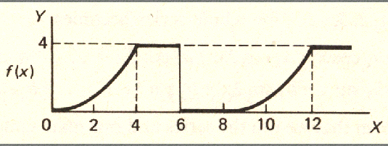

► 0

► 4

► 6

► 8

Question No: 18 ( Marks: 1 ) - Please choose one

Let denotes the Laplace Transform.
If 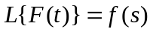 where is a constant.and 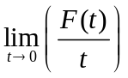 exists then which of the following equation holds?

► 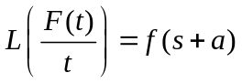

► 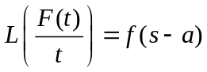

► 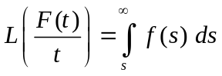

► 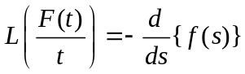

Question No: 19 ( Marks: 1 ) - Please choose one

Which of the following is Laplace inverse transform of the function 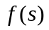defined by 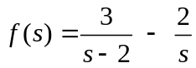?

► 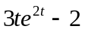

► 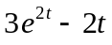

► 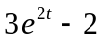

► None of these.

Question No: 20 ( Marks: 1 ) - Please choose one

Let 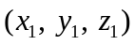 and 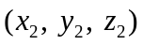 be any two points in three dimensional space. What does the formula 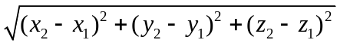calculates?

► Distance between these two points

► Midpoint of the line joining these two points

► Ratio between these two points

Question No: 21 ( Marks: 1 ) - Please choose one

Let the functions 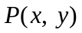and 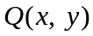 are finite and continuous inside and at the boundary of a closed curve C in the xy-plane. If 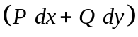 is an exact differential then
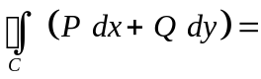

► Zero

► One

► Infinite

Question No: 22 ( Marks: 1 ) - Please choose one

What is Laplace transform of the function 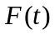 if 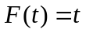?

► 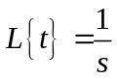

► 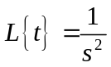

► 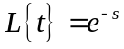

► 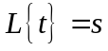

Question No: 23 ( Marks: 1 ) - Please choose one

What is the value of 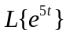if denotes laplace transform?

► 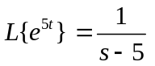

► 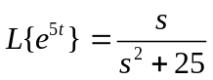

► 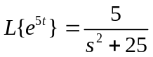

► 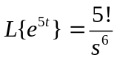

Question No: 24 ( Marks: 1 ) - Please choose one

Evaluate the line integral 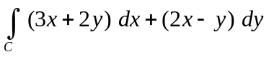 where C is the line segment from (0, 0) to (0, 2).

► 1

► 0

► 2

► -2

Question No: 25 ( Marks: 1 ) - Please choose one
Evaluate the line integral 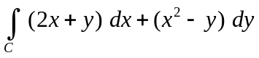 where C is the line segment from (0, 0) to (2, 0).

► 0

► -4

► 4

► Do not exist

Question No: 26 ( Marks: 1 ) - Please choose one
Which of the following are direction ratios for the line joining the points 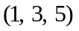and 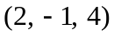?

► 3, 2 and 9

► 1, -4 and -1

► 2, -3 and 20

► 0.5, -3 and 5/4

Question No: 27 ( Marks: 1 ) - Please choose one

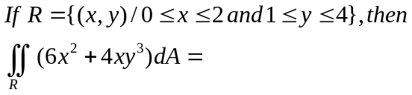

► 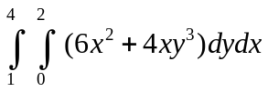

► 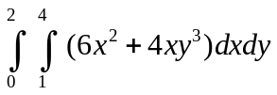

► 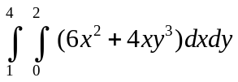

► 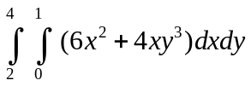

Question No: 28 ( Marks: 1 ) - Please choose one

Which of the following is true for a periodic function whose graph is as below?
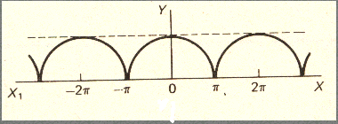

► Even function

► Odd function

► Neither even nor odd function

Question No: 29 ( Marks: 1 ) - Please choose one

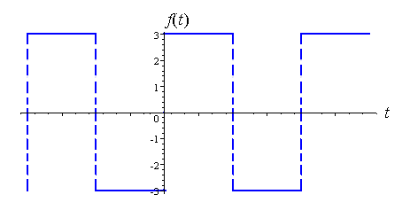
Which of the following is true for a function whose graph is given above

► An odd function

► An even function

► Neither even nor odd

Question No: 30 ( Marks: 1 ) - Please choose one

At each point of domain, the function ----------------

► Is defined

► Is continuous

► Is infinite

► Has a limit

Question No: 31 ( Marks: 2 )

Determine whether the following differential is exact or not.
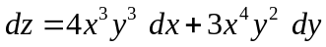
Solution:
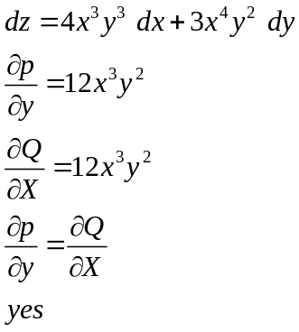

Question No: 32 ( Marks: 2 )
Evaluate
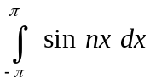
where n is an integer other than zero.

Solution:

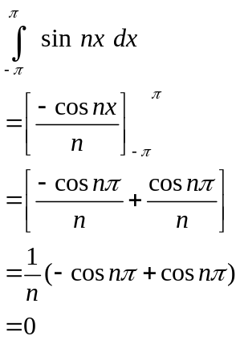

Question No: 33 ( Marks: 2 )

Find Laplce transform of the function if 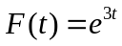

Solution:
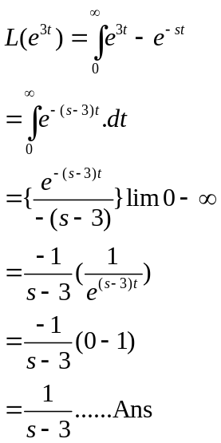

Question No: 34 ( Marks: 3 )

Determine the Fourier co-efficient 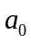of the periodic function defined below:
Solution:
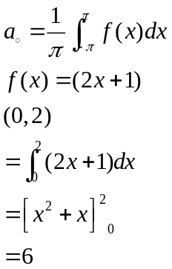

Question No: 35 ( Marks: 3 )

Determine whether the following differential is exact or not.
Solution:

dz = Pdx + Qdy

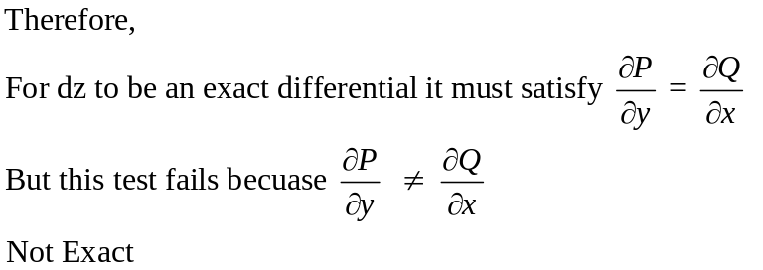

Question No: 36 ( Marks: 3 )
Use Wallis sine formula to evaluate 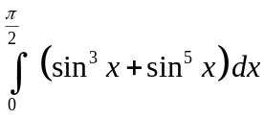

Solution:

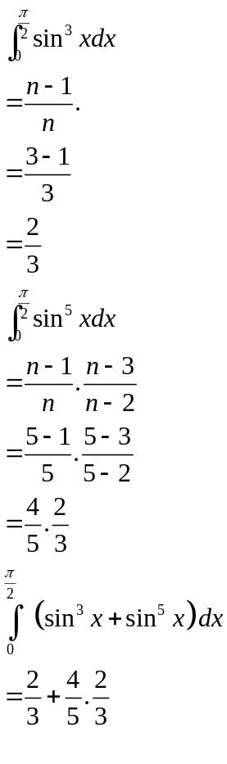

Question No: 37 ( Marks: 5 )

Evaluate the following line integral which is independent of path.
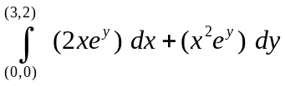
Solution:

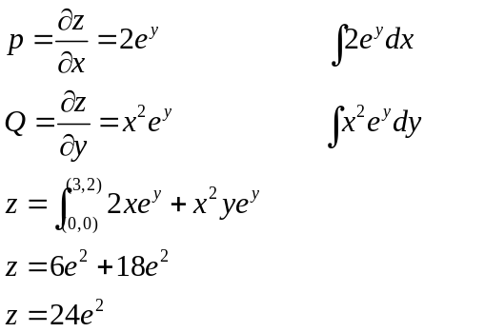

Question No: 38 ( Marks: 5 )

Determine the Fourier coefficients 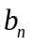for a periodic function  of period 2 defined by
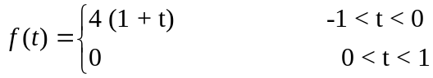
Solution:

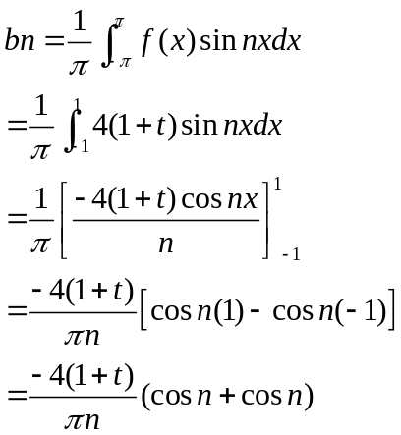

Question No: 39 ( Marks: 5 )

Determine whether the following vector field 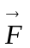 is conservative or not.



